**Drought Legacies/Legacy and Implications for Soil Microbial Systems Resilience/Stability**

**Questions to address:**

1. **How would the magnitude of legacy effects determine the extent/duration of delay?**

It is hypothesized that the magnitude of drought legacy effects depends on the strength of community-level trade-off between tolerance and enzyme investment driven by drought pressure.

The higher the community tolerance and the lower the community enzyme investment, the stronger the legacy effects. However, how to increase community drought tolerance?

- sensitivity of inducible osmolyte production to drought (closely associated with drought level).

- magnitude of constitutive production of osmolyte(which can modulate the tradeoff strength by damping the benefit/increasing the cost of drought tolerance derived from inducible production). This is because constitutive production does not, in the specific structure of inducible cost-benefit pair assumption, offer a benefit to microbes.

1. **How to reconcile ‘ecological memory’ and ‘legacy’? Does memory equal legacy?**

For now, memory is equal to legacy. The only difference is in the narrative: take drought disturbance for example; it is eligible to say microbial system memory of drought and drought legacy in microbial systems. From the modeling perspective, we could say DEMENTpy memory of drought. Can a model have memory of an environmental disturbance?

1. What factors would determine the duration of a legacy arising from drought disturbance?

In other words, how long would a system memorize the drought disturbance? System matters. The disturbance matters as regards severity, duration, and frequency.

1. Specifically, how would legacy effects relate to resilience?
2. How do microbial systems keep resilient? Mechanisms?
3. How to quantify resilience? In terms of what? CUE or litter mass?
4. How to manipulate the sensitivity of DEMENTpy to water/moisture?
5. Does production of osmolyte reduce respiration?
6. How to incorporate other mechanisms of microbes confronting drought stress?

**1 Introduction**

Understanding natural systems resilience is one of the central themes in Ecology. This is all the more so in the context of ever accelerating global environmental changes, a pressing challenge to confront for natural systems to keep stable in avoidance of collapse. Otherwise, services they provide with respect to biogeochemical cycling/biosphere-atmosphere interactions and human sector needs would simply not be able to sustain. Natural systems are inherently complex, and understanding how systems complexity (in terms of diversity and their interactions) mediates ecological systems functioning is particularly essential for/integral to elucidating mechanisms underpinning systems’ resilience responding to environmental changes (refs). Across natural systems in the biosphere, we have gained knowledge relatively a lot from plant-based systems. However, for microbial systems it is even more challenging to address because of much higher diversity and methodological barriers. With a high diversity in natural microbial systems, how legacies of disturbances would form and thereby influence resilience of natural systems is yet unknown to a large extent. Increasing drought severity and frequency is one of the most pressing threats regionally and worldwide (refs), and therefore how would drought legacy affects microbial systems responding to drought disturbances and thus affect their resilience?

How drought affects microbial communities has been an active research field since the pioneering work by Birch (1958), who reported that soil drying and rewetting can cause large pulses in nutrient mineralization and soil respiration. Now with research of over half of a century, huge progress has been made in understanding how water conditions affect microbial systems across organizational levels. In general, underlying mechanisms involve physical, chemical, and biological, as well as ecological ones (refs). First, reduced water availability limits substrate diffusivity and accessibility, albeit increasing the oxygen transport rate, thus lowering microbial growth (Or et al. , 2007; Manzoni et al. , 2012). This is evidenced by the apparent lack of sensitivity of the respiration curves to climate and microbial community composition, suggesting that **at low water availability** factors other than physiology (or community composition) may control respiration. Microorganisms protect themselves against large, negative soil matric and osmotic potentials through the acquisition of protective osmolytes (Csonka 1989; Harris 1981; Borken and Matzner, 2009; Schimel et al., 2007; Schimel 2018). Bacteria typically use amino compounds such as proline, glutamine, and glycine betaine (Csonka 1989), while fungi use polyols such as glycerol, erythritol, and mannitol (Witteveen and Visser 1995). In summary, these cellular-scale metabolic and physiological mechanisms could cause fewer resources to invest in enzymatic machinery (Sardans and Penuelas 2010) and reduces respiration (refs). Eventually, by altering the balance of growth and maintenance, changes in soil water might affect the microbial CUE. For instance, Tiemann & Billings (2011) hypothesized a shift from development to protection against water stress and reported a decline of CUE with an increasing drought. Given the amount of osmolyte production in culture-based studies, the ecosystem consequences of production and subsequent loss of osmolytes would be significant, potentially consuming 3 - 6% of net primary production and accounting for 10 - 40% of annual net N mineralization in grasslands (Schimel et al., 2007). However**,** though with a relatively better understanding of microbial physiology and metabolisms at the individual cell level, ecological processes at the community-level underpinning microbial systems responses to drought is **still in its infancy**. How would interactions between individuals within a microbial community change responding to changes in moisture conditions? Knowing these interactions between individuals compromising a system is essential to elucidating mechanisms underpinning microbial systems functioning. Though with these understandings across scales encompassing physical, biological, and ecological mechanisms, how drought disturbances cascade into legacies and thus affect microbial systems functioning and resilience are largely unknown.

To elucidate drought legacy formation and its relationship with resilience, it is essential to incorporate all these components of processes/mechanisms supporting microbial systems functioning into understanding how microbial systems form ‘memories’ of drought disturbances, among which microbial community diversity is especially important. This diversity-induced complexity results in a myriad of difficulties with respect to methodological incorporation of diversity and mechanistic details including both field and lab experiments and mechanistic models among others. This study aims to shed light on this grand issue by applying a spatially and mechanistically explicit microbial systems model to a natural microbial system focused on the disturbance of drought. To proceed, we need to confront the challenges arising from the tremendous diversity of microbial systems and rich processes. Either field manipulative studies or lab experiments have their own limitations. Instead, we seek help from theory-guided models that are able to incorporate diversity to overcome these challenges, at least partly and preliminarily. Specifically, an individual-based microbial system model applying a trait-based approach, which can bridge across scales from individual cell through community to system, fulfills the requirements.

Whether can a microbial system keep resilient in response to drought disturbances? This study addressed this overarching question with the spatially explicit trait- and individual-based microbial systems modelling framework—DEMENTpy (v1.0). Specifically, we tackled questions including how would legacy affect microbial systems responses? Why can the legacy effects exist? In detail, we examined these questions regarding functions in terms of litter decomposition. Answers to these questions together indicate the unequivocal importance of microbial system complexity in mediating microbial systems functioning and systems stability, as well as the legacy effects (which results in delays in processes in a microbial system) it mediated via drought-driven compositional changes. More broadly, this study opens up a door to in-depth investigations into rules of microbial community assembly and structure and implications for modelling microbial systems interacting with soil organic matter dynamics.

**2 Methods**

## **2.1 Model description**

DEMENTpy (DEcomposition Model of ENzymatic Traits, v1.0) is a spatially explicit trait- and individual-based microbial systems modelling framework built upon its predecessor DEMENT (Allison 2012; Allison and Goulden 2017; Wang and Allison 2019). Overall, this model has six core modules, one module initializing spatially explicit microbial community on the spatial grid and other data about substrate, monomers, and enzymes and the remaining five modules dealing with five major processes, each targeting a major process in a soil microbial system spanning from degradation of substrates and uptake of monomers through metabolism to mortality and reproduction, which are driven by abiotic factors of temperature and moisture (**Fig.1**). Specifically, these modules are described in detail below but with an emphasis on those components that are moisture-related, aiming to only reiterate the major updates here for clarity. All other aspects of each module are only briefly described, and readers are referred to the earlier works using earlier versions of this model for more details (Allison 2012; Allison and Goulden 2017). All these processes are achieved in DEMENTpy with 8 modules (six core modules plus two supporting ones) programmed in Python with a hierarchical design (see supporting figure; GitHub Repository: https://github.com/bioatmosphere/DEMENTpy). This redesign is expected to make the model more accessible and convenient to a wider community to modify and/or to improve in future research.

### **2.1.1 Initialization of microbial community**

This module is the core of implementing the trait-based modelling approach by assigning trait values to different taxa, each with a different combination of values of those traits applied. This module creates the proxy taxa by randomly drawing values from distributions of microbial traits (tradeoffs?) and assigning them to different taxa. These taxa with differing combinations of traits values form a spatially-explicit microbial community. Traits available are shown in Figure 2, among which moisture-related traits include osmolyte production rate. Currently, trait distributions are all assumed to follow uniform distributions, except that for simplicity, some traits are assumed to be constants (e.g., cell quota; reference CUE, etc.). These distributions/assumptions largely arise from information scarcity (unlike the relative maturity of plant traits; refs). It is noteworthy that values of some traits are derived from tradeoffs between traits (further elaborate). Once these proxy taxa are created, the simulation proceeds without any differences with the traditional individual-based modelling approach, and processes executed are described immediately below.

### **2.1.2 Processes simulated**

Processes spanning from substrates degradation and monomers uptake through microbial metabolism to mortality and reproduction are explicitly simulated. Microbial reproduction is simply calculated by splitting microbes into two halves, which disperse to other cells on the grid. The governing equation of substrates’ degradation follows the Michaelis-Menten equation. Substrates are calculated explicitly by using different enzymes with different kinetic properties. One principle during the simulation is that every substrate at least has one enzyme to degrade and vice versa. The central governing equation of monomers’ uptake follows the Michaelis-Menten equation. Different monomers are calculated explicitly by having differing transporters to target them. Transporters of different types and amounts are taxon-specific, which is described immediately below. Moisture influences these processes via affecting enzymatic kinetics and monomers’ uptake.

Metabolism module explicitly deals with both the carbon upon uptake from the surrounding environment and the carbon in biomass of microbial cells. The metabolic processing of carbon includes processes/components ranging from uptake respiration, growth respiration, enzyme production (and respiration), and osmolyte production (and respiration) are explicitly calculated. The uptake C left after these processes accumulates toward biomass.

Production of osmolytes is calculated as a function of water potential, and the osmolytes produced in the cell either transports to the outside or stay inside the cell. First, a relationship between soil water potential and pool size of protectants could be first established. This relationship should be influenced by taxon drought tolerance. This will eventually affect the growth efficiency. Introduce a drought tolerance trait in terms of allocation of assimilated C to protectants instead of the drought tolerance trait previously used by Allison et al. (2017).

Microbial mortality is simulated deterministically by accounting for mass balance and stochastically by constraining death probability by drought tolerance and moisture. Microbes that are starving (according to …) are designated as dead ones and then removed from the microbial community. These dead microbes are added into the substrates pools as dead microbes. Moisture in terms of water potential affects mortality.

From these underlying processes, emergent ~~CUE~~ and respiration are then calculated for each microbial cell and hence for the whole system. In detail, each component’s calculation and underlying rationale are described below. Uptake respiration is simply a proportion of biomass.

## **2.2 Modelling experiments**

We parameterized DEMENTpy to the grassland system in Loma Ridge, Southern California with respect to plant litter, environmental data of daily temperature and moisture (in terms of water potential). We benchmarked DEMENTpy(v1.0) with the daily whether data of year 2012, which is treated as the base scenario (data visualized).

On top of this base scenario we did a series of simulations examining the effects of drought disturbances of different severity with a series of scenarios (Fig.xx) on microbial communities in terms of responses spanning from physiology through community to the system level functions. Specifically, we did reciprocal simulations to examine the drought disturbances and implications for microbial communities degrading substrates. To further examine how dispersal affects drought legacy, we also included simulations that accounting for dispersal.

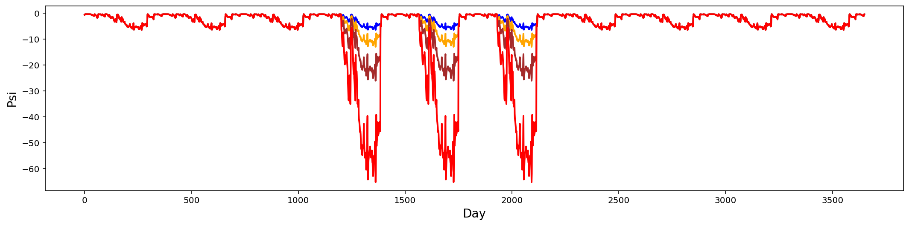

**Fig. xx** Drought scenarios considered for legacy.

## **2.3 Simulation protocol**

We initialized our model by including initial pools of substrates and monomers, as well microbial biomass with 100 different proxy taxa. These substrates data are based on grass litters at Loma Ridge, Southern California. We setup the simulation on a lattice with a size of 100×100 grid.

With the model setup as described above, we follow the protocol as follows for conducting actual simulations (of which the rationale is discussed): each simulation run for 10 years, and in each new year substrates, monomers, and enzymes are reinitialized with the same configurations as the very beginning. In particular, microbial community on the spatial grid is randomly moved around in each new year with an initialization strategy based on frequency of each taxon on the grid in the last day of the previous year. However, in dispersal mode the frequency is based on cumulative biomass of each taxon across the previous whole year. For each simulation, we repeatedly run 20 times with different seeds, and all results presented below, unless notified otherwise, are analyses of such an ensemble of 20 runs.

## **2.4 Data analysis**

We extracted output data including substrates and microbes.

Statistics (seed = random factor)

# **3 Results**

## **3.1 Microbial system dynamics**

Seasonal and inter-annual dynamics in terms of drought tolerance and enzyme investment, as well as their relationship.



Fig. xx Microbial system dynamics.

## **3.2 Drought disturbance and microbial system responses (and recovery)**

When drought of different severity is imposed, degradation of substrates over the grid were significantly dampened.

When imposing back the base scenario, we can still clearly see the changes in degradation…. However, the magnitudes across the scenarios were dampened. …

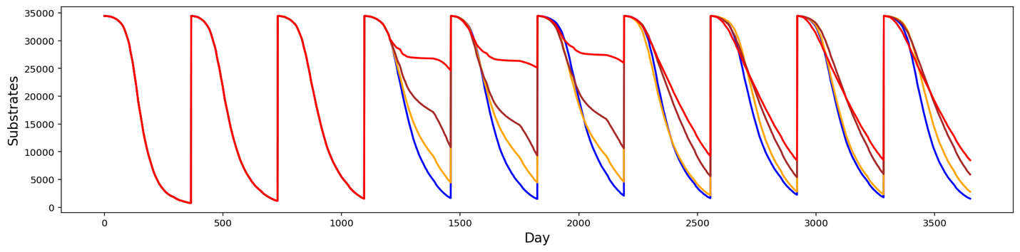

**Fig.xx Impacts of drought legacy on substrates’ degradation**

Corresponding to the degradation changes, microbial community was altered by the drought of differing severity as well.

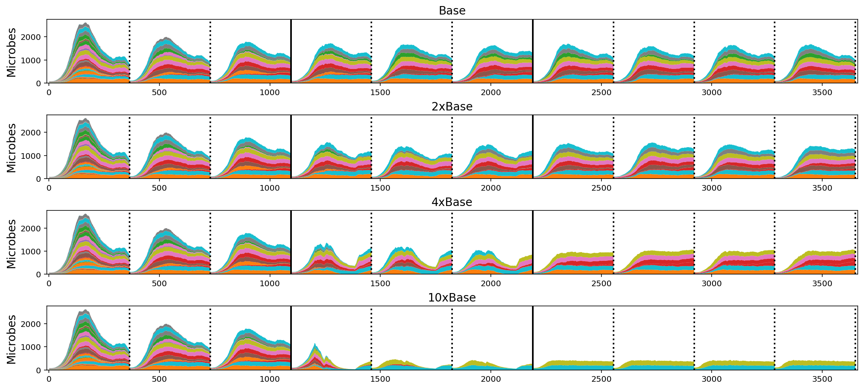

Fig.xx. Drought-driven community shift arising from legacy.

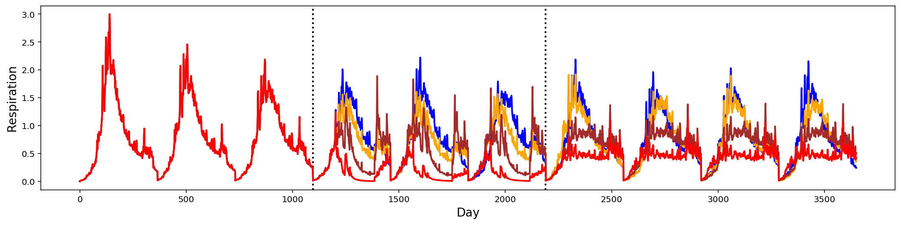

Fig.xx. Respiration (Supporting figure?)

**3.3 Dispersal**

….

**3.4 Sensitivity**

# **4 Discussion**

## **4.1 Microbial system dynamics across season**

Seasonal dynamics with respect to litter mass loss, biomass, and respiration reflect a joint control of environment and microbial community. Starting from a wet season and relatively replete with substrates, microbial community consisting of different taxa established and flourished. However, as substrates depleted, microbial cells started to be starved and die. This is accompanied by increasing drought while entering the drought season, which induced more death. These two processes in combination resulted in the decline of microbial biomass. Where is temperature?

It is noteworthy that fungi are generally considered being more tolerant than bacteria to soil drying. This higher drought tolerance of fungi is due to their filamentous structure that enables the accumulation of osmoregulatory solutes without impairing metabolism via reaching and exploiting substrates even at very low soil moisture levels (Griffin 1980, 1981; Freckman 1986; Magan and Lynch 1986; Brown 1990; Manzoni et al. 2012b).

## **4.2 Drought legacy and microbial system resilience**

Legacy of a disturbance in principle can be in various forms that occur along with each other. With drought we may expect legacies of materials besides only community, which, however, is the only focus of this study. The drought legacy is embedded in microbial community change, which is expressed in terms of the tradeoff between community-level drought tolerance and community-level resource acquisition, which results in declined degradation of substrates when even having the same environmental forcing. Drought-induced community shift results in a decline in capability degrading substrates in the system, and the magnitude of this effect positively correlated with drought severity (cite works in this regard).

Drought legacy forms a new stable microbial system (Fig. xx). Moreover, this new stable state can last and carry the legacy effects forever into the future. In line with the bi-stability of boreal forest biome across Eurasia and North America because of the legacy of the last glacial (Herzschuh 2019 GEB).

However, this new stable system does not necessarily always stand. Dispersal is a key process that can negate the existence of this stable system (Fig. xx). We imagine different stable systems could exist depending on dispersal. In line with the bi-stability of boreal forest biome across Eurasia and North America because of the legacy of the last glacial (Herzschuh 2019 GEB).

## **4.3 Deficiencies of processes simulated**

Deficiencies pertaining to the study *per se* are manifold, which can be grouped into these categories: missing processes, structural biases, and parameter uncertainties. Reasons leading to these deficiencies are manifold as well; however, these issues do not necessarily undermine the robustness of our conclusions.

Although this model is explicit in terms of metabolism, it is still in its infancy in really capturing intracellular metabolisms which are fairly complex and entail both data accumulation and gap bridge from research communities of modelling and experiment within the microbial ecology domain . For example, CUE calculation, though improved, is still semi-explicit, which in the current version a constant reference value (0.5) is applied across all taxa. One source of drought protection is the manufacture of a layer of polysaccharide-rich mucilage that prevents desiccation (Borken and Matzner, 2009). Second is to explicitly separate the total live biomass into active (BA) and dormant (BD) pools (e.g., Bäret al., 2002; Stolpovsky et al., 2011). These pathways have not yet been considered in the current version. Metabolic network modelling advancements (Sauer and Teusink 2018) are accelerators in this regard, which could fuel a close coupling with DEMENTpy. Additionally, when the soil is re-wetted, microorganisms can release these osmolytes quickly to protect themselves against osmotic pressure and cell lysis; otherwise, they could burst due to excessive water movement into the cell (Csonka 1989).

Evolution is not simulated yet in the current version. This can be a fruitful avenue for future development. The trait-based modelling framework of vegetation by Scheiter el al. (2013) is inspirational in this regard. ‘Reproduction is a key element in next-generation DGVMs, as it transfers traits from one generation to the next (inheritance), allows transfer of traits between reproductive individuals (crossover) and allows novel trait values to enter through mutation (Scheiter *et al.* 2013)’.

Deficiencies regarding bounded rationality; that is, this whole study did not consider the aboveground litter input determined by plant activities. If it is coupled with above-ground processes of litter input and plant-microbe nutrient competition, we anticipate even more meaningful insights into whole ecosystem functioning. These, however, are beyond the scope of this investigation.

Additionally, the legacies that drought can potentially induce are not fully accounted for in this modelling exercise, which include among others dead microbes, dead enzymes, and microbial community change, as discussed earlier. This study emphasized only community shift.

## **4.4 Broader implications for modelling microbial systems, soil systems, and ecosystems**

This modelling system can be used to address questions broadly related to the relative roles of environmental disturbance vs community in controlling microbial systems dynamics and functioning. Trait-based approach in combination with individual-based modelling is a feasible approach investigating microbial community ecology bridging physiology and systems functioning. This applicability in microbial systems expands to other natural systems across the biosphere, especially vegetations (which are the most obvious one that has seen widespread applications).

This study holds broad implications for biosphere modelling in the context of ever increasing frequency of environmental changes that must incorporate legacy effects or enable models capture microbial community memory of disturbances. This memory would enable more accurate quantification of soil biogeochemical cycling of various elements and above- and below-ground interactions. Knowledge gained will eventually feed our predictive understanding towards carbon cycling in soil systems in the context of projected global climate change.

First of all, legacies of environmental disturbances should be incorporated into ecosystem models. This is broadly true across natural systems comprised by different organisms with varying disturbances. For example, legacy effects of the last glacial shaped a bi-stable boreal biome of evergreen-dominated North America versus Deciduous dominated Eurasia (Moncrieff et al. 2015 GEB). Additionally, ozone stress is an issue for vegetation heath and productivity, and because of compositional shift ozone does not necessarily introduce any productivity declines (Wang et al. 2016).

This advocation for including legacy poses huge challenges for developing and improving models, especially large scale ecosystem models. One of the challenges is scaling that resolves transcending of spatial and temporal boundaries. Finally, this study raises questions about how to scale up local scale explicit microbial community simulation to larger scale modelling by land surface models. To achieve regional and even global modelling, a prerequisite is global information on distribution of microbial traits’ distributions (like plants economic spectrum of microbial traits needs to be uncovered. Also multi-dimensional trait space is waiting to be unearthed). Then with a generic trait-based modelling framework, as illustrated by DEMENTpy, globally explicit simulation could be achieved. Of course, this requires companion datasets of soil moisture and temperature, which is already available (Green et al. Nature 2019).

# **References**

Birch, H. F. 1958. The effect of soil drying on humus decomposition and nitrogen availability. Plant and Soil 10, 9–31.

Csonka, L. N. (1989). Physiological and genetic responses of bacteria to osmotic stress. Microbiological reviews, 53, 121-147.

Gommers, P. J. F., Van Schie, B. J., Van Dijken, J. P., & Kuenen, J. G. (1988). Biochemical limits to microbial growth yields: an analysis of mixed substrate utilization. *Biotechnology and bioengineering*, *32*, 86-94.

Hobbie, J. E., & Hobbie, E. A. (2013). Microbes in nature are limited by carbon and energy: the starving-survival lifestyle in soil and consequences for estimating microbial rates. *Frontiers in Microbiology*, *4*, 324.

López-Urrutia, Á., & Morán, X. A. G. (2007). Resource limitation of bacterial production distorts the temperature dependence of oceanic carbon cycling. *Ecology*, *88*, 817-822.

Manzoni, S., Schimel, J. P., & Porporato, A. (2012b). Responses of soil microbial communities to water stress: results from a meta‐analysis. *Ecology*, *93*, 930-938.

Manzoni, S., Taylor, P., Richter, A., Porporato, A., & Ågren, G. I. (2012a). Environmental and stoichiometric controls on microbial carbon‐use efficiency in soils. New Phytologist, 196, 79-91.

Sardans, J., & Peñuelas, J. (2010). Soil enzyme activity in a Mediterranean forest after six years of drought. Soil Science Society of America Journal, 74, 838-851.

Scheiter, S., Langan, L., & Higgins, S. I. (2013). Next‐generation dynamic global vegetation models: learning from community ecology. New Phytologist, 198, 957-969.

Schimel, J., Balser, T. C., & Wallenstein, M. (2007). Microbial stress‐response physiology and its implications for ecosystem function. Ecology, 88, 1386-1394.

Schimel, J. P., & Weintraub, M. N. (2003). The implications of exoenzyme activity on microbial carbon and nitrogen limitation in soil: a theoretical model. Soil Biology and Biochemistry, 35, 549-563.

Sinsabaugh, R. L., Manzoni, S., Moorhead, D. L., & Richter, A. (2013). Carbon use efficiency of microbial communities: stoichiometry, methodology and modelling. Ecology Letters, 16, 930-939.

Tiemann, L. K., & Billings, S. A. (2011). Changes in variability of soil moisture alter microbial community C and N resource use. *Soil Biology and Biochemistry*, *43*, 1837-1847.

Yao, Q., Li, Z., Song, Y., Wright, S. J., Guo, X., Tringe, S. G., ... & Mayes, M. A. (2018). Community proteogenomics reveals the systemic impact of phosphorus availability on microbial functions in tropical soil. Nature Ecology & Evolution, 1.

# **Acknowledgements**

…